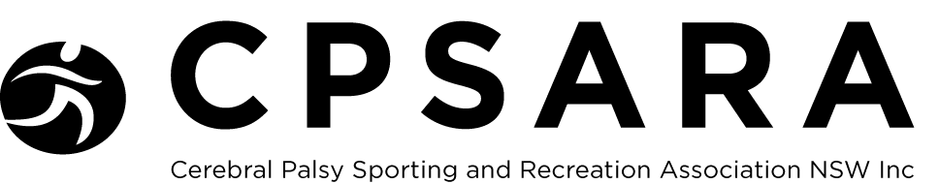

Membership 2022

MEMBERSHIP TYPE (indicate with: X)

All membership types $30

New Membership: |  | Membership Renewal:
Athlete: | Coach: |  | Official:
Family: | Health professional: |  | Classifier:

member Information

Name:

Date of birth:

Address:

City: |  | State:
ZIP Code: |  | Country:
Your email address:

Family email address:

Diagnosed disability:

Have you been diagnosed with cerebral palsy (Yes/No):

Sport and recreational activities
Sport and recreational activities you are interested in:

Sport classification(s): e.g. Athletics – T36

PLEASE RETURN TO: CPSARA, P.O. Box 243, KENSINGTON, NSW 1465 OR VIA EMAIL @ SECRETARY@CPSARA.ORG.AU

please indicate payment method with x

Direct Debit |  | Cheque
Postal Order |  | PayPal
AMOUNT PAYABLE $30 ANNUAL MEMBERSHIP FEE
Direct Debit: Commonwealth Bank Australia BSB: 06 2256 Account No: 1005 5647
Cheques payable to: The Cerebral Palsy Sporting And Recreation Association Of New South Wales Inc.
PayPal: via website: www.cpsara.org.au

Member decleration
I/We HEREBY AGREE TO ABIDE BY THE RULES OF THE ASSOCIATION ON THE CPSARA WEBSITE.
I/We HEREBY AGREE/NOT AGREE (please delete one) TO THE ASSOCIATION USING MY PROFILE AND IMAGES TO PROMOTE THE ASSOCIATION.
CPSARA will collect and store the information you voluntarily provide to enable processing of your membership. Any information provided by you will be stored on a database that will only be accessed by authorised personnel and is subject to privacy restrictions. The information will only be used for the purpose for which it was collected.

Signature(S)
Signature: |  |  |  | Date:
Signature of parent/guardian ( if member is under 18 years): |  |  |  | Date:

